Documentation
- Dashboard

- Expected:
  - I was expecting to have a brilliant UI, where I didn’t need to have any experience in designing UI.
- Actual:
  - I was amazed by the UI it designed for a chat application with multiple features. The UI was responsive, and there was smooth transitioning; the color palette was also good.
  - I was expecting that while doing a video call to a single user, my video would be visible, but it wasn’t.
  - There was also a problem in generating chat summary.
- Friction Points:
  - There were no friction points. It was so simple to build.
- Bugs or errors:
  - No bugs or errors were present.
- Missing or Unclear steps:
  - The steps were simple and clear.
- Outdated or incorrect documentation:
  - It was up to date.
- Suggestions:
  - In my chat application, while sending texts to other users, I was expecting a response. You can improve this.

- UI Kit Builder

- Expected:
  - I was expecting it to be easy to implement on my system.
- Actual:
  - It was easy to download. It was also easy to set up on my system.
- Friction Points:
  - There were no friction points.
- Bugs or errors:
  - No bugs or errors were present.
- Missing or Unclear steps:
  - The steps were simple and clear.
- Outdated or incorrect documentation:
  - It was up to date.
- Suggestions:
  - The process from building to exporting it was so simple and easy that it doesn’t need any setup guide or anything. It’s perfect.

- Documentation

- Expected:
  - I was thinking that the Documentation was going to be very lengthy and complicated.
- Actual:
  - The documentation was so creative and concise.
- Friction Points:
  - There were no friction points. It was so simple to read the documentation.
- Bugs or errors:
  - No bugs or errors were present.
- Missing or Unclear steps:
  - The steps were simple and clear.
- Outdated or incorrect documentation:
  - It was up to date.
- Suggestions:
  - No suggestions.

- Actual UI Kit Implementation

- Expected:
  - I was expecting it to be difficult. Also expecting it to be the same as shown on the Comet Chat UI.
- Actual:
  - It was so simple to implement the UI kit. All I need to do is unzip the file and run 'npm install'. That was it. After deploying it on my system, it was not identical to the Comet Chat UI.
  - Features were missing, like in the group as well as in a single user chat; there were features of the collaboration whiteboard and collaboration document. Stickers were also missing.
  - While sending text, it shows a runtime error. (photo is attached below)
  - 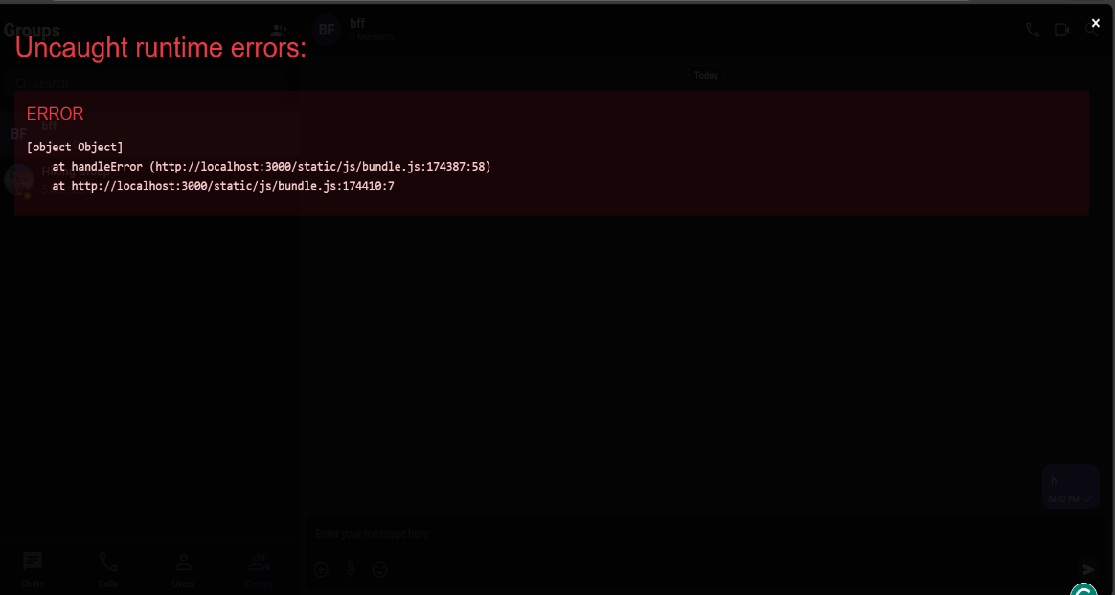
There was also an issue while doing a video call to a single user; it didn’t show my video.
- Friction Points:
  - There were no friction points. It was so simple to build.
- Bugs or errors:
  - No bugs or errors were present.
- Missing or Unclear steps:
  - The steps were simple and clear.
- Outdated or incorrect documentation:
  - It was up to date.
- Suggestions:
I want you to display all the features after deploying on local systems same as on your site.

